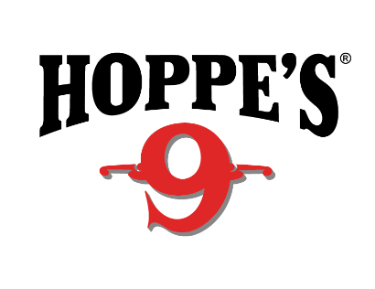 Contact: Kristen Veverka
Communications Manager
Tactical Products & Shooting Accessories
(913) 689-3630
FOR IMMEDIATE RELEASE E-mail: pressroom@vistaoutdoor.com

Hoppe’s Adds Competitive Shooter Lena Miculek to Ambassador Line-Up of Rising Shooting Stars

OVERLAND PARK, Kansas (April 10, 2018) – Hoppe’s, the best known name in gun care products, announces the signing of Lena Miculek to Hoppe’s Sponsored Shooter Program. She will represent Hoppe’s at USPSA and 3 Gun competitions, as well as assess and develop new products.

Miculek is a competitive shooter from Arkansas, who started shooting competitively at just 8 years old. Working as a full time professional competitive shooter for 6 years now, her past accomplishments include placing in the lady division at the NRA World Shooting Competition, IPSC Rifle World Shoot in Russia and High Lady at the USPSA Optic Nationals with PCC.
“Hoppe’s represents some of the best people in the competition shooting world,” Miculek said. “I knew if they were trusting Hoppe’s products to keep their equipment running, it had to be the best. The long history the company has and the vast product lines really made it a sure thing for me to be interested in joining the Hoppe’s team. I get to represent one of the most iconic companies in the industry. Hoppe’s truly cares and supports all aspects of the firearms industry and its enthusiast’s.”
“We are so excited to add such a valuable member of the shooting community to the Hoppe’s team,” said Jason Slinkard, Hoppe’s Brand Director. “She is a true competitor with an extremely impressive skill set, and I know she will be an excellent representative of our brand.”
Hoppe’s, a Vista Outdoor brand, serves shooters of all disciplines, and offers gun care products that meet the rigorous standards Frank Hoppe established more than 110 years ago. Visit the website at www.hoppes.com.

About Vista Outdoor
Vista Outdoor is a leading global designer, manufacturer and marketer of consumer products in the growing outdoor sports and recreation markets. The company operates in two segments, Shooting Sports and Outdoor Products, and has a portfolio of well-recognized brands that provides consumers with a wide range of performance-driven, high-quality and innovative products for individual outdoor recreational pursuits. Vista Outdoor products are sold at leading retailers and distributors across North America and worldwide. Vista Outdoor is headquartered in Utah and has manufacturing operations and facilities in 13 U.S. States, Canada, Mexico and Puerto Rico along with international customer service, sales and sourcing operations in Asia, Australia, Canada, and Europe. For news and information, visit www.vistaoutdoor.com or follow us on Twitter @VistaOutdoorInc and Facebook at www.facebook.com/vistaoutdoor.

###

